This graph tell the relevant, irrelevant and duplicate for each question 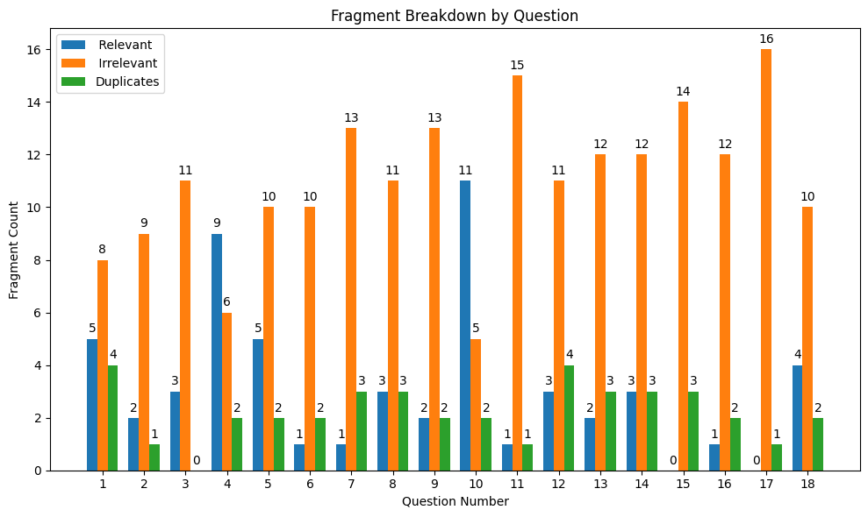

This tells us about the accuracy of each bucket for question. That is the result fragments are split into 3 equal buckets to see if the kendra is able to return more relevant answers in the first bucket than 2nd and the 2nd returns more relevant answers that the 3rd

